Bayer UK & Ireland

Carbon Reduction Plan

Supplier name: Bayer UK & Ireland PLC
Publication date: 5th March 2026

Commitment to achieving Net Zero

Bayer is committed to achieving Net Zero emissions by 2045

Baseline Emissions Footprint
Baseline emissions are a record of the greenhouse gases that have been produced in the past and were produced prior to the introduction of any strategies to reduce emissions. Baseline emissions are the reference point against which emissions reduction can be measured.

Baseline Year: 2019
Additional Details relating to the Baseline Emissions calculations.
Baseline year emissions:
EMISSIONS | TOTAL (tCO₂e)
Scope 1 | 2,052.7
Scope 2 | 333.8
Scope 3  (Included Sources) | 88,146.7  (Categories 1, 2, 4, 6, 7)
Total Emissions | 90,533.2

Current Emissions Reporting
Reporting Year: 2025
EMISSIONS | TOTAL (tCO₂e)
Scope 1 | 563.98
Scope 2 | 0
Scope 3  (Included Sources) | 59,736.1  (Categories 1, 2, 4, 6, 7)
Total Emissions | 60,300.0

Emissions reduction targets

In order to continue our progress to achieving Net Zero, we have adopted the following carbon reduction targets.

Bayer to reduce Scope 1&2 Emissions by 42% by 2030* from 2019 Baseline.

Bayer to reduce Scope 3 Emissions by 25% by 2030* from 2019 Baseline. *SBTi verified

Initiatives to reduce Carbon Footprint:
Reduction plan for Scope 1, 2 and 3:
Before 2025:
- 100% renewable electricity purchase for Reading, Cambridge, Dublin offices and Farms
- Dublin office move to smaller and more efficient premises
- Reading Office space reduced by 1 floor (from 3 to 2)
- Investment in equipment to reduce F-Gas emissions released
- Launch of Sustainable Business Travel Guide, ways to reduce emissions impact
- Customer collaboration for optimised and efficient delivery transport emissions (scope 3 category 4)
- Annual sustainability survey measuring and capturing Home Working and Commuting emissions
- Transition of company owned car fleet to EV, currently +20%
Cut of c.+ 3,000 tonnes of CO2e since 2019

2025- 2030
- Cambridge office move to more sustainable and efficient premises
- 100% electric Bayer car fleet by 2029
- Business Travel flight restrictions and enhanced web-based video conferencing capabilities
- Additional Customer logistics collaborations and efficiencies
- 3rd Party Logistics Provider to move from Diesel fuel to BioFuel
Targeted cut of approx. 2,000 tonnes of CO2e emissions

Post- 2030
- All Bayer UKI offices in zero rated buildings
- Product-based emission reduction initiatives

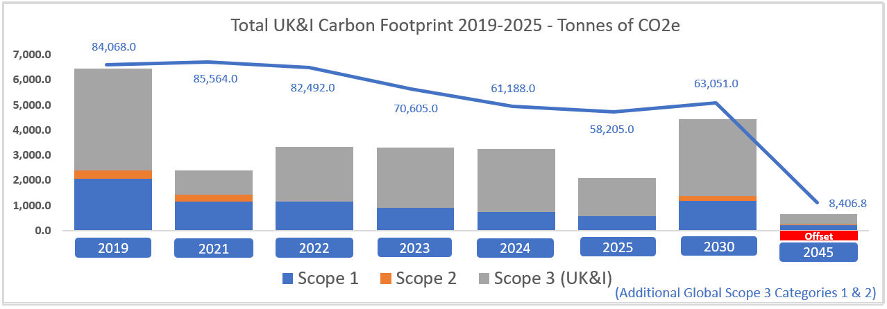

Sign off:

Andy Clarke

Andy Clarke
Head of Sustainability and Public Affairs UK & Ireland
Bayer Well-Being of Future Generations Team

////////////////////
Bayer Public Limited Company
400 South Oak Way
Reading
RG2 6AD
Great Britain

